**GENERAL HUMAN BIOLOGY – YEAR 12**

**TASK 7 – MICROSCOPE PRACTICAL**

**NAME: _______________________________________ WEIGHTING: 7%**

**DATE: _______________________________ MARK: _______ / 38 =_______ %**

***PART A – MICROSCOPE QUESTIONS [TOTAL =19 MARKS]***

1. Label the parts of the microscope in the picture below: [12 marks]

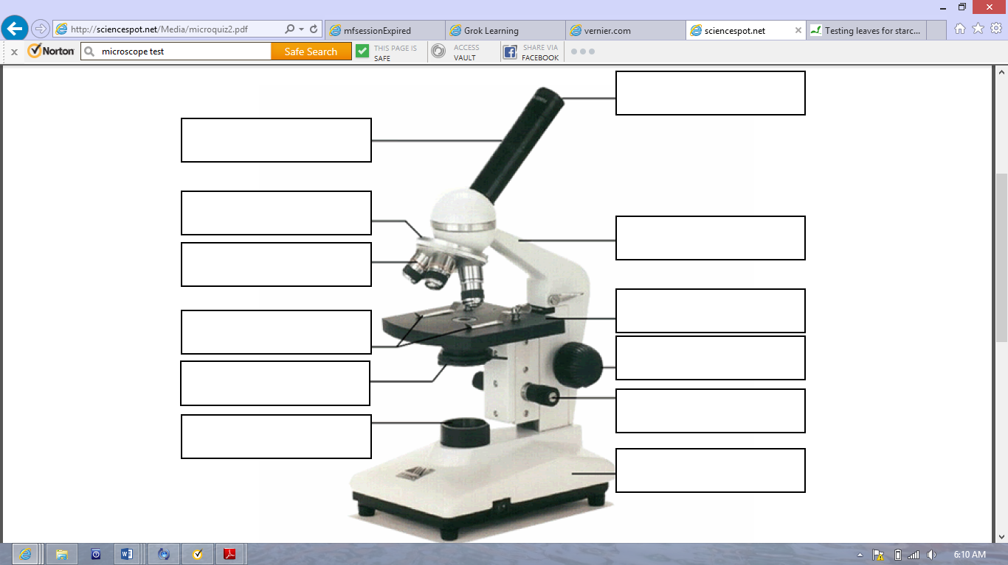

1. Calculate the missing information in the table below, using your knowledge of the powers of magnification. Make sure you SHOW YOUR WORKING IN THE SPACE PROVIDED TO GET FULL MARKS

[4 marks]

|  |  |  |  |
| --- | --- | --- | --- |
| OCULAR LENS | OBJECTIVE LENS | POWER OF MAGNIFICATION | WORKING OUT |
| 10 | 4 |  |  |
| 5 |  | 200 |  |
|  | 10 | 120 |  |

1. How does the view of a specimen on a microscope slide change as you increase the power of magnification ? [2 marks]

______________________________________________________________________________________________________________________________________________________________

______________________________________________________________________________________________________________________________________________________________

1. When should you *always* use the fine focus knob ? [1 mark]

______________________________________________________________________________________________________________________________________________________________

***PART B –USING A MICROSCOPE [TOTAL = 12 MARKS]***

Gut health and the microbiome is increasingly becoming an area interest within health sciences. It has been found that infectious diseases are more likely to occur when a person’s microbiome is diminished. Consumption of antibiotics and a diet that is heavy in meat and low in plant material has led to many people in the western work turning to probiotics and probiotic enriched foods.

Probiotics are live bacteria that are help keep the gut remain healthy. Kefir is a fermented milk drink that originated in the Caucasian Mountains near Turkey, where it was used for centuries as a healthy drink. It contains *Lactobacillus, Lactococcus, Leuconostoc* and *Saccharomyces kefir.*

***AIM:* To investigate bacteria present in kefir and regular milk.**

***MATERIALS:***

* 2 x Glass slides
* 2 x Cover slips
* 2 x Pipette
* Microscope

***METHOD:***

1. Create a slide of the kefir - Place a few droplets onto the slide; ensure that there are no bubbles.
2. View under the microscope – low, medium and high power.
3. Draw what you see under the best magnification (power) for viewing the specimen in the space provided. Include the ocular and objective lens magnification and calculate the total magnification of your image
4. Include any other observations in the space next to your drawing.
5. Repeat the process for the full cream milk.

***OBSERVSATIONS:*** [8 marks]

Draw what you saw under the best magnification. *The bacteria will look like round cells with dots inside.*

Kefir:

Full cream milk:

***ANALYSIS:***

1. Which slide showed the most bacteria? [1 mark]
2. What power allowed you to view the bacteria the best? [1 mark]
3. Justify your answer for Question 6? [2 marks]

***PART C –APPLICATIONS [TOTAL = 8 MARKS]***

1. As scientists have improved microscopes, so too has our understanding of micro-organisms such as bacteria and viruses. Why do you think this is so? [1 mark]
2. Answer the following calculations:
   1. 5210 µm = ________________ mm [1 mark]
   2. 0.154mm = ________________ µm [1 mark]
   3. A microscope has a Field of View of 2.5cm at magnification 40x.
      1. Convert the Field of View to micrometres = ________________ µm [2 marks]  
         *Show working here:*
      2. If the magnification was increased to 400x, what would the new Field of View be? = __________________ µm [2 marks]  
         *Show working here:*

***END OF TEST***